25.03.2026
International Trade and Economics (Econ303)

Seyit Mustafa Turhan
Data Assigment

Data Source :
The trade data used in this project were obtained from the UN Comtrade Database (https://comtradeplus.un.org/).
Date: March 20, 2026
Type of product: Goods
Frequency: Annual
Classification: SITC Rev.4, 1-digit level (AG1)
Reporters: Japan
Partners: Spain
Trade flows: Exports and imports
Period: 2020–2024 (all available years)
Modes of transport: Total
2nd partner: World
Customs code: Total

Required Information: The data were downloaded as an Excel file and then processed using R. The original variables include refYear, flowDesc, cmdCode, cmdDesc and primaryValue. All values are reported in dollars but for analysis they were converted to nominal dollars and aggregated.
Summary of Japan-Spain Trade:
Overall Trade Volume and Balance:
Table1 reports total annual exports( JP to SP), imports( JP from SP) and trade volume.
Trade balance (NEX) is shown in Table2.

Table1: Total Exports, Imports and Trade Volume (current USD)
Year | Export (million $) | Import (million $) | Trade Volume (million $)
2020 | 2,185.9 | 3,165.7 | 5,351.6
2021 | 2,423.2 | 5,384.7 | 7,807.9
2022 | 2,703.5 | 6,860.7 | 9,564.2
2023 | 3,284.3 | 4,925.9 | 8,210.3
2024 | 3,157.0 | 3,779.8 | 6,936.8
Source: UN Comtrade, own calculations

Table2: Japan’s Trade Balance with Spain (current USD)
Year | Net Exports (million $)
2020 | –979.9
2021 | –2,961.5
2022 | –4,157.3
2023 | –1,641.6
2024 | –622.8

(Negative values indicate a trade deficit for Japan.)

Observations:
- Japan runs a trade deficit with Spain. The deficit widened sharply from 2020 to 2022 (-4.16 B$ in 2022) and then narrowed in 2023-2024.
- Trade volüme increased by nearly %80 from 2022 to 2022, but then declined by %27 from the peak in 2022 to 2024. This pattern reflects the post-COVID rebound followed by global economic slowdown and inflationary pressures.

Product Consumption:
Table3 shows that the average annual trade values (Million $) for each SITC1-digit category over 2020-2024 period. The figures are calculated as the mean of yearly totals for imports and exports separately.

Table3: Average Annual Trade by Product Category (million USD)
SITC | Product Category | Avg. Imports | Avg. Exports
0 | Food and live animals | 20.25 | 973.02
1 | Beverages and tobacco | 2.00 | 142.19
2 | Crude materials, inedible, except fuels | 22.52 | 270.87
3 | Mineral fuels, lubricants and related materials | 13.18 | 180.27
4 | Animal and vegetable oils, fats and waxes | 0.56 | 202.56
5 | Chemicals and related products, n.e.s. | 211.83 | 1,737.98
6 | Manufactured goods classified chiefly by material | 349.98 | 185.32
7 | Machinery and transport equipment | 1,866.14 | 673.63
8 | Miscellaneous manufactured articles | 126.75 | 449.67
9 | Commodities not classified elsewhere | 137.56 | 7.88

Key Insights:
- Japan’s exports to Spain are dominated by Chemicals( SITC5) and averaging 1.74 billion USD per year which accounts about %54 of total average exports. This is followed by Food and live animals (SITC0) with 973 million USD (%30 of exports) and Machinery and Transport equipment(SITC7) with 674 million USD(%21 of exports).
- Japan’s imports from Spain are heavily dominated by Machinery and transport equipment(SITC7) and averaging 1.87 billion USD per year, representing about %49 of total average imports. Manufactured goods(SITC6) and Chemicals(SITC5) also pay a significant role, with 350 and 212 million USD perspectively.
- There is a substantial intra-industry trade in machinery(SITC7) and Chemicals(SITC5): both categories are among the largest in both directions, although the net balance differs

Evolution of Product Shares:
The share of each product category in total trade(IM+EX) over time is illustrated in Figure1.

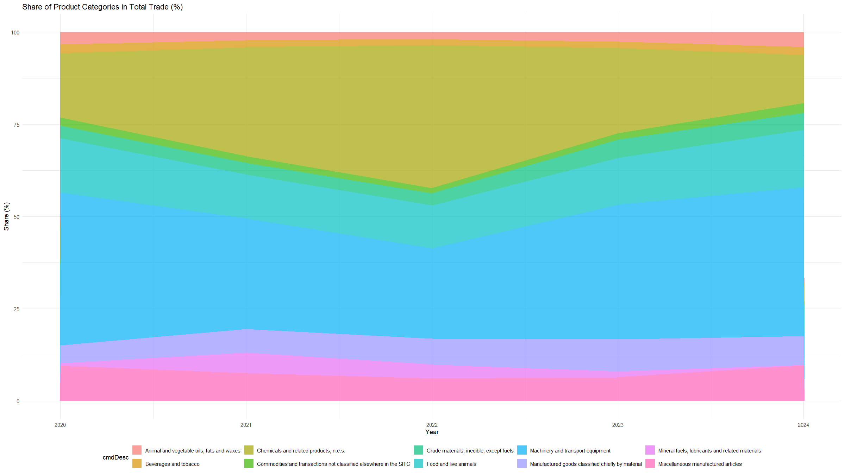

- The share of Machinery and transport equipments(SITC7) increased around %10 in 2020 to over %35 in 2022, them declined to about %15 by 2024.
- Chemicals(SITC) maintained a relatively stable share of %20-%25 throughout the period.
- Food and live animals(SITC0) showed a notable rise from %5 in 2020 to %15 in 2024, reflecting the growth of Japanese food exports to Spain

Correlation between Exports and Imports:
The correlation coefficient between annual export and import values is 0.106. It is indicating very weak positive relationship. This suggests that the two flows do not move in tandem; periods of high imports do not systematically coincide with high exports, which is consistent with the idea that bilateral trade is driven by different product-specific factors.

Adjusment for GDP:
GDP data for adjust the trade values and analyze the relative importance of Japan–Spain trade over time. All figures are expressed in current US dollars (million) to ensure comparability. The GDP data for Spain and Japan are organized as follows:
Spain GDP (million USD):
- 2020: 1,290,000
- 2021: 1,461,245
- 2022: 1,448,851
- 2023: 1,620,000 (approx.)
- 2024: 1,591 billion euros → converted at average 2024 exchange rate of 1 EUR = 1.08 USD ≈ 1,718,280
Japan GDP (million USD):
- 2020: 5,056,000
- 2021: 5,035,000
- 2022: 4,256,000
- 2023: 4,213,167
- 2024: 4,027,598
Trade as a Share of GDP:
Using the annual export and import values (million USD) from the earlier analysis, compute the following ratios:
Table4: Japan – Trade with Spain as % of Japan’s GDP
Year | Exports to Spain (mil USD) | % of Japan GDP | Imports from Spain (mil USD) | % of Japan GDP
2020 | 2,186 | 0.043% | 3,166 | 0.063%
2021 | 2,423 | 0.048% | 5,385 | 0.107%
2022 | 2,704 | 0.064% | 6,861 | 0.161%
2023 | 3,284 | 0.078% | 4,926 | 0.117%
2024 | 3,157 | 0.078% | 3,780 | 0.094%
(Basic calculations with calculator)

Table5: Spain – Trade with Japan as % of Spain’s GDP
Year | Exports to Japan (mil USD) | % of Spain GDP | Imports from Japan (mil USD) | % of Spain GDP
2020 | 3,166 | 0.245% | 2,186 | 0.169%
2021 | 5,385 | 0.369% | 2,423 | 0.166%
2022 | 6,861 | 0.474% | 2,704 | 0.187%
2023 | 4,926 | 0.304% | 3,284 | 0.203%
2024 | 3,780 | 0.220% | 3,157 | 0.184%
(Basic calculations with calculator)

Interpretation:
- For Japan, both exports and imports as a share of GDP increased substantially from 2020 to 2022, reflecting the trade-liberalising effect of the EU–Japan Economic Partnership Agreement (EPA) and the post-COVID recovery. Imports peaked at 0.16% of Japan’s GDP in 2022, then declined to 0.09% in 2024, while exports stabilised around 0.078% in 2023–2024. The sharp fall in the import share after 2022 mirrors the nominal decline in imports and the simultaneous fall in Japan’s GDP.
- For Spain, the bilateral trade is much more significant relative to it’s economy. Exports to Japan (Japan’s imports from Spain) reached 0.47% of Spain’s GDP in 2022, more than double the 2020 level. Imports from Japan (Spain’s purchases) also rose but remained below 0.2% of Spanish GDP throughout. This asymmetry indicates that for Spain, Japan is a more important export market than for Japan, Spain is an import source.
- GDP-adjusted series confirm that the surge in trade between 2020 and 2022 was not solely driven by inflation or exchange rate movements, it represented a genuine increase in the economic weight of the bilateral relationship. The subsequent decline in 2023–2024, while present in nominal terms, appears less dramatic when measured against GDP, especially for Japan’s exports, which held their share.
- The correlation between exports and imports(0.106) remains weak even after GDP adjustment, reinforcing the earlier conclusion that the two flows are largely driven by independent product-specific factors rather than a simple reciprocal exchange.

Conclusion of GDP adjustment:

Adjusting for GDP provides a clearer view of the evolution of trade intensity. It reveals that the bilateral trade between Japan and Spain gained considerable economic importance during 2020–2022, especially for Spain, and that the recent nominal contraction only partly reflects a decline in relative economic significance. This adjustment also strengthens the theoretical interpretation: the observed patterns align with the EU–Japan EPA boosting trade, and the persistent two-way trade in machinery and chemicals remains consistent with intra-industry specialisation (new trade theory) rather than a simple factor-proportions story.

Theoretical Interpretation:
Ricardian Model:
The Ricardian model emphasizes differences in labour productivity as the source of comparative advantage. Japan and Spain both have advanced economies, but Japan has historically been a leader in high-tech manufacturing (e.g., electronics, automotive) while Spain has strengths in agriculture, food processing, and some capital goods.
The observed pattern shows that Japan exports chemicals (a technologically sophisticated sector) and food products (which might include processed food and beverages) to Spain, while importing machinery and transport equipment from Spain. This could be interpreted as each country specializing in different sub-sectors where they have a productivity edge. However, the large two-way trade in machinery and chemicals is not easily explained by simple Ricardian comparative advantage, because productivity differences alone would typically lead to one-way specialization.

Heckscher-Ohlin Model:
The Heckscher-Ohlin model predicts that a country exports goods that intensively use its abundant factors. Japan is generally considered capital-abundant and skill-abundant, whereas Spain is relatively labor-abundant(still developed country).
One would therefore expect Japan to export capital-intensive goods (e.g., chemicals) and import labour-intensive goods (e.g., textiles, some agricultural products). Our data partially support this:
- Japan’s exports are dominated by chemicals (capital-intensive).
- Japan’s imports include manufactured goods (SITC 6) which may be more labour-intensive, and also machinery – but machinery is capital-intensive, which contradicts the simple Heckscher-Ohlin prediction.
The existence of large two-way trade in machinery suggests that factor-endowment differences alone cannot explain the entire trade pattern. Within the machinery category, there may be intra-industry trade in differentiated products (e.g., automotive parts, electronic components) that is better captured by models of monopolistic competition and economies of scale.
“While the Heckscher-Ohlin model effectively explains the inter-industry trade patterns observed—such as Japan’s capital-intensive machinery exports versus Spain’s land-intensive food exports —the data also reveals significant bidirectional trade in SITC 5 (Chemicals). This specific trend suggests the presence of intra-industry trade, which is better captured by the theories explored in Chapter 5. Rather than being driven solely by factor abundance, this exchange likely stems from economies of scale and product differentiation. It indicates that both Spain and Japan leverage specialized technological niches within the chemical industry to exchange differentiated goods, a phenomenon that standard comparative advantage models might overlook.”

New Trade Theory and Intra-Industry Trade:
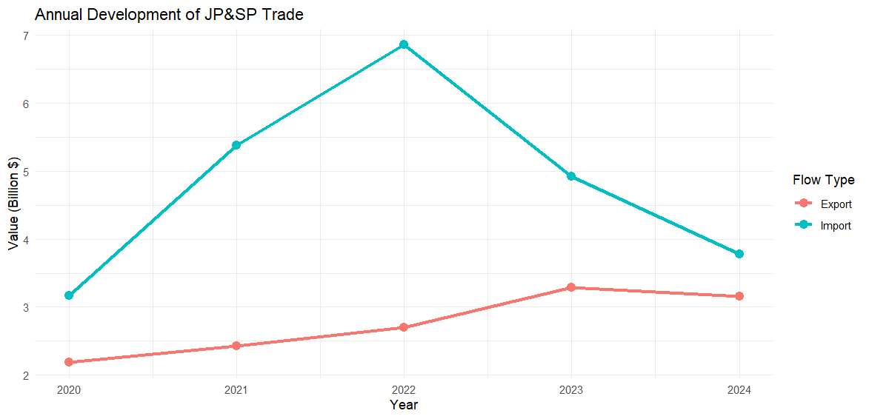
The Grubel‑Lloyd (GL) index measures the extent of two‑way trade within the same industry. Values ​​close to 1 indicate perfect intra‑industry trade, while values ​​near 0 reflect one‑way (inter‑industry) trade.
SITC 6 (Manufactured goods) and SITC 7 (Machinery and transport equipment) exhibit the highest GL indices, averaging 0.69 and 0.53 respectively. This indicates substantial two‑way trade in these sectors, consistent with product differentiation and economies of scale - the central tenets of new trade theory. Japanese and Spanish firms produce specialized varieties of machinery and manufactured goods, and the EU‑Japan EPA has facilitated such exchange.
SITC 0, 1, 2, 3, and 4 (food, raw materials, fuels, oils) have very low GL values ​​(below 0.15). Trade in this categories is predominantly one‑way, reflecting traditional comparative advantage (e.g., Spain's agricultural exports vs. Japan's chemical exports).
SITC 5 (Chemicals) shows a moderate GL of 0.22, suggesting a mix of inter and intra‑industry trade. While Japan is a net exporter of chemicals, there is still some two‑way flow, possibly due to specialization within sub‑categories.

The high GL indices for SITC 6 and 7 strongly support the relevance of new trade theory for Japan‑Spain bilateral trade. Rather than being driven solely by factor endowments (Heckscher‑Ohlin) or productivity differences (Ricardo), these sectors benefit from scale economies and consumer demand for variety, leading to simultaneous exports and imports.
Role of Trade Agreements and Barriers:
Since 2019, the EU–Japan Economic Partnership Agreement (EPA) has progressively eliminated tariffs on a wide range of goods. The EPA covers machinery, chemicals, food products, and many other categories. The substantial increase in trade between 2020 and 2022 (both exports and imports) likely reflects the positive impact of this agreement, as tariffs were reduced or removed. The subsequent decline in 2023–2024 might be attributed to global economic headwinds (energy crisis, inflation) rather than a reversal of the trade liberalisation.

Conclusion:
The bilateral trade between Japan and Spain exhibits several notable features:
- Japan runs a persistent trade deficit, with imports exceeding exports in every year of the sample.
- Machinery and transport equipment (SITC 7) is the largest category in both directions, indicating strong intra-industry trade.
- Japan’s exports are concentrated in chemicals and food products, while its imports are dominated by machinery and manufactured goods.
- Trade volume surged after the EU-Japan EPA came into effect, but contracted in 2023–2024, probably due to macroeconomic factors.
Among the trade theories reviewed, the Heckscher-Ohlin model provides some insight into the net factor content (capital-intensive exports vs. labour-intensive imports), but the simultaneous two-way trade in capital-intensive goods is better explained by new trade theory (increasing returns and product differentiation). The weak correlation between export and import aggregates further supports the view that bilateral trade is shaped by intra-industry specialisation rather than a simple exchange of factor services.
For a more complete analysis, future work could incorporate GDP-deflated values and explore disaggregated (2-digit or 3-digit) SITC data to better capture the nature of intra-industry trade.
References
- UN Comtrade Database. (2026). International Trade Statistics. Retrieved March 20, 2026, from https://comtradeplus.un.org/
- European Commission. (2019). EU-Japan Economic Partnership Agreement.
- Krugman, P. (1980). “Scale Economies, Product Differentiation, and the Pattern of Trade.” American Economic Review, 70(5), 950–959.

Sources used in the research:
- https://www.lamoncloa.gob.es/lang/en/gobierno/news/paginas/2025/20250910-sp-japan-economic-cooperation.aspx
- https://www.elibrary.imf.org/view/journals/002/2025/121/article-A001-en.xml
- https://economic-research.bnpparibas.com/html/en-US/Spain-rich-growth-momentum-continues-12/18/2025,53109
- https://oec.world/en/profile/bilateral-country/esp/partner/jpn
- https://oec.world/en/profile/bilateral-country/jpn/partner/esp
- https://www.hoosieragtoday.com/2025/12/08/asf-spain-impact/
- https://wits.worldbank.org/trade/country-byhs6product.aspx?lang=en

AI Chat: https://gemini.google.com/share/2174455312c0

